METHODOLOGY NOTE
Building the charts from respondent level data extract using Python
A methodology for reducing manual QC risk and improving turnaround time
How to load raw data, ground Claude on the calculation, and generate a trusted Excel output for any complex repeated analytical slide — eliminating manual QC risk and reducing turnaround time.

What this document covers
This note describes a reusable three-step methodology for automating repeated analytical slides using Python and Claude. Two worked examples are used — a simpler CNPS channel chart (static, one-click refresh) and a more complex brand attributes chart (interactive, subjective filter selections). The methodology is the same in both cases; the complexity of the implementation scales with the complexity of the slide.

1. The problem this approach solves
Many analytical slides require the same underlying calculation to run repeatedly — across providers, regions, channels, time periods, or market segments. In the manual process this means:
- Pulling respondent-level or view-level data from an extract each wave
- Filtering to each required dimension combination — provider, wave, region, channel, etc.
- Pivoting or aggregating to compute the metric, rebuilding for every combination
- Manually running significance calculations in a separate reference sheet
- Copying values into each chart backend — repeated for every provider on every slide
- Restarting from scratch if a filter selection, provider order, or scope changes
The result is a process that is slow, hard to QC, and prone to silent errors — particularly on filter combinations like model year ranges or rolling period definitions that shift every wave.

2. The methodology — three steps
The same three steps apply regardless of the slide type or complexity of the calculation.
Step 1 — Load the data
Upload the view data extract or respondent-level file to Claude. This gives Claude the data structure — column names, field types, how the data is organised — before any code is written.
Step 2 — Ground Claude on the calculation
Share a screenshot of the Tableau tooltip formula or a QC pivot that shows how the metric is computed. Ask Claude to replicate one specific value and validate it against the dashboard before asking for the full output. This is the step that makes the output trustworthy.
Step 3 — Specify the Excel format and ask Claude to build the code
Share a screenshot of the slide and the chart backend. Specify the rows, columns, period definitions, provider order, significance rule, and any cell mapping needed for Excel macros. Claude generates the Python code that produces the output.
Do not ask Claude to output data values without first validating the calculation against the dashboard. Always ground Claude on the formula and confirm one cell before trusting the full output.

3. Two worked examples
The methodology is illustrated through two examples at different levels of complexity. Both follow the same three steps — the implementation differs based on how many subjective filter decisions the analyst needs to make at runtime.
 | Example A — CNPS channel chart | Example B — Brand attributes chart
Slide type | Channel NPS bars by provider and region | Brand attribute % top 2 box by provider
Complexity | Simpler — fixed structure, standard filters | Complex — multiple sets, shifting model years, stat sig
Filter decisions | None at runtime — fully determined by the data | Subjective — analyst selects periods, model years, providers
Code interaction | Static — run once, no terminal prompting | Interactive CLI — numbered menus for every filter
Refresh process | Swap the data file, run the script, done | Re-run the script and answer the prompts for the new scope
Output | 8 slide tables updated in one click via macro | Excel with 3 time periods + stat sig arrows per provider
When to use | When the structure is fixed and filters are clear | When filter combinations are subjective or change per slide
EXAMPLE A — SIMPLER CASE
CNPS Channel Chart
Static code · No terminal interaction · One-click refresh across all slides

The slide
The target output is a P&C channel NPS slide showing bar chart values for Digital, Call Center, and Broker/Agent channels, across multiple providers, for two rolling periods (current Q4 and prior year Q4). The same structure is repeated across multiple region and comparison combinations — All Canada, Quebec, Rest of Canada, YoY, and QoQ.
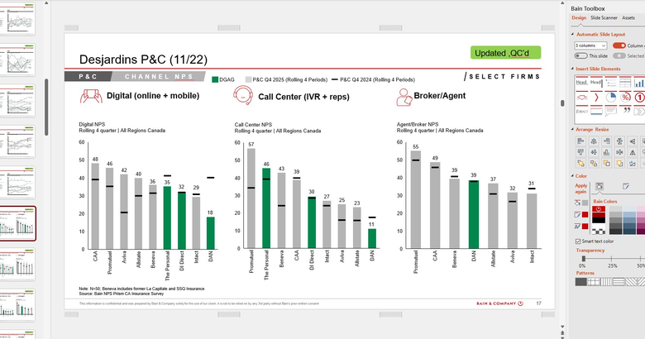
This slide is produced for Desjardins P&C. The green bars represent the selected brand (DGAG). The black lines are the prior year comparison. The same chart structure repeats across 8 slides covering different region and period combinations.

Why this is a good candidate for static automation
- Fixed structure: The same calculation runs across 8 combinations of region × comparison period. No subjective filter decisions.
- Period auto-detection: The code identifies the latest rolling quarter present in the data and automatically derives the YoY and QoQ comparison periods. No manual period selection each wave.
- Provider renaming: Provider names in the raw data are mapped to display names required by the slide — handled in the code, not manually.
- Cell mapping for macro: Output is written to specific cells in the Excel backend so that an existing macro can push all 8 charts into think-cell in one click.

Step 1 — Load the data and understand the structure
The CNPS view data extract is uploaded directly to Claude. The key fields Claude needs to understand are shown in the view data panel below.
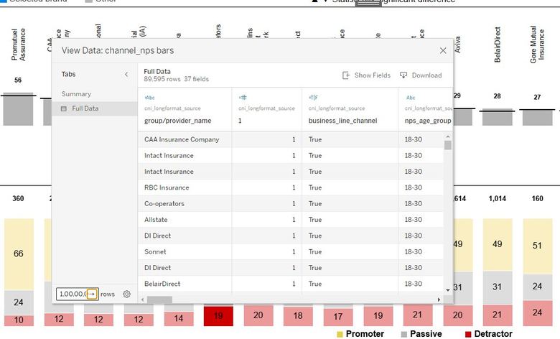
The view data has 89,595 rows and 37 fields. Claude reads the structure from this upload — field names, data types, and how provider names appear in the raw data — before any code is written.
Key columns Claude needs to understand for this calculation:
Column | What it contains
group/provider_name | OEM / insurer name as it appears in the raw data
business_line_channel | Channel flag — Digital, Call Center, Broker/Agent
channel_period Set | Rolling period indicator — used to identify which quarter each respondent belongs to
nps_nps_weight | Survey weight applied to each respondent
nps_nps_category_value | NPS category value — Promoter (+1), Passive (0), Detractor (-1)
region | Geographic region — All Canada, Quebec, Rest of Canada

Step 2 — Ground Claude on the calculation
The CNPS formula is shared as a screenshot of the Tableau tooltip calculated field. This shows Claude exactly how the weighted NPS score is computed from the raw data.
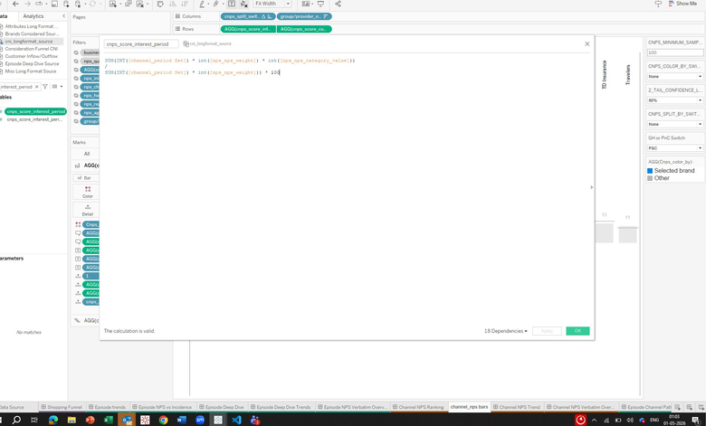
The formula: SUM(INT([channel_period Set]) × int([nps_nps_weight]) × int([nps_nps_category_value])) divided by SUM(INT([channel_period Set]) × int([nps_nps_weight])) × 100. Claude reads this directly from the screenshot and replicates the logic in Python.
Before asking Claude to generate the full output, ask it to compute the CNPS value for one specific provider, one channel, and one period. Compare that single number against the dashboard. Only once it matches should you proceed to the full output.

Step 3 — Specify the output format and build the code
The slide screenshot is shared with Claude along with the Excel backend structure. Claude is told:
- The output must cover 3 channels × 3 regions × 2 comparison types (YoY + QoQ) = 8 slide combinations
- Each combination needs current period values and prior period values for all providers
- Provider names must be mapped from raw data names to display names used in the slide
- Output must be written to specific named cells in the Excel so the existing macro can run without modification
- The code must auto-detect the latest rolling quarter in the data — no hardcoded period labels
Because period detection is automatic, the refresh process for the next wave is:
Refresh process — Example A
1. Replace the view data file with the new extract. 2. Run the Python script. 3. The script detects the new latest quarter automatically. 4. All 8 tables are written to the correct cells. 5. Run the Excel macro — all 8 slides update in one click. No code changes. No terminal prompting.

The Python code
The complete script is shown below with comments embedded explaining each section. The code has six logical parts. Only Section 1 (Configuration) needs to be edited between runs or wave refreshes.
import pandas as pd
import sys
from openpyxl import Workbook, load_workbook
from openpyxl.styles import Font, PatternFill, Alignment, Border, Side
from openpyxl.utils import get_column_letter
from openpyxl.utils.cell import coordinate_from_string, column_index_from_string
from datetime import datetime

# =============================================================================
# SECTION 1 -- CONFIGURATION
# This is the ONLY section you need to edit between runs.
# All other sections run automatically based on these values.
# =============================================================================

CSV_PATH = "cnps_CNI_Desjardins_view_data_extract.csv" # <-- update each wave refresh
OUTPUT_PATH = r"CNI_Desjardins_Output.xlsx" # <-- full path to your Excel file

ROLLING = 4 # Rolling window size in quarters (R4 = standard; change to 1/2/3 if needed)

# CELL_MAP: maps each (channel, region, comparison_type) combination to a
# specific Excel cell reference. This is how output lands in the right place
# for the macro. As long as this map is correct, the macro does not need to change.
# region_key: 1 = All Regions Canada | 2 = Quebec | 3 = Rest of Canada
# comparison_type: "YoY" = 4 quarters back | "QoQ" = 1 quarter back

CELL_MAP = {
("Digital", 1, "YoY"): "B238", # Digital | All Canada | Year-on-Year
("Digital", 2, "YoY"): "B247", # Digital | Quebec | Year-on-Year
("Digital", 3, "YoY"): "B256", # Digital | Rest of CA | Year-on-Year
("Digital", 1, "QoQ"): "B265", # Digital | All Canada | Quarter-on-Quarter
("Digital", 2, "QoQ"): "B274", # Digital | Quebec | Quarter-on-Quarter
("Digital", 3, "QoQ"): "B284", # Digital | Rest of CA | Quarter-on-Quarter
("Call Center", 1, "YoY"): "N238",
("Call Center", 2, "YoY"): "N247",
("Call Center", 3, "YoY"): "N256",
("Call Center", 1, "QoQ"): "N265",
("Call Center", 2, "QoQ"): "N274",
("Call Center", 3, "QoQ"): "N284",
("Broker/Agent", 1, "YoY"): "Z238",
("Broker/Agent", 2, "YoY"): "Z247",
("Broker/Agent", 3, "YoY"): "Z256",
("Broker/Agent", 1, "QoQ"): "Z265",
("Broker/Agent", 2, "QoQ"): "Z274",
("Broker/Agent", 3, "QoQ"): "Z284",
}

# =============================================================================
# SECTION 2 -- CONSTANTS
# Defined once per engagement. Update only if scope changes: new provider,
# new channel label, new region split, or slide column order changes.
# =============================================================================

ALL_REGIONS = [
"Alberta", "British Columbia", "Manitoba", "New Brunswick",
"Newfoundland and Labrador", "Nova Scotia",
"Nunavut / Northwest Territories", "Ontario",
"Prince Edward Island", "Quebec", "Saskatchewan", "Yukon"
]

REGION_OPTIONS = {
1: ("All Regions Canada", ALL_REGIONS),
2: ("Quebec", ["Quebec"]),
3: ("Rest of Canada", [r for r in ALL_REGIONS if r != "Quebec"]),
}

# Maps raw channel values in the data to the three slide channel groups
CHANNEL_GROUPS = {
"Digital": ["(Digital) Mobile app", "(Digital) Online"],
"Call Center": ["(Human) Call center IVR", "(Human) Call center rep"],
"Broker/Agent": ["(Human) Insurer/ Agent branch", "(Human) Broker"],
}

CHANNEL_DISPLAY = {
"Digital": "Digital (online + mobile)",
"Call Center": "Call Center (IVR + reps)",
"Broker/Agent": "Broker/Agent",
}

# Maps raw CSV provider names to short slide display labels.
# Eliminates manual renaming -- handled automatically by the script.
PROVIDER_DISPLAY_NAMES = {
"CAA Insurance Company": "CAA",
"The Personal": "Personal",
"Desjardins Agent Network": "DAN",
"Allstate": "Allstate",
"DI Direct": "DI Direct",
"Intact Insurance": "Intact",
"Aviva": "Aviva",
"Promutuel Assurance": "Promutuel",
"Beneva": "Beneva",
}

# Left-to-right column order per (region_key, channel).
# Must match the slide layout exactly. Update here if order changes.
# MOST COMMON THING TO UPDATE when engagement manager requests a scope change.
PROVIDER_ORDER = {
(1, "Digital"): [
"Allstate", "Aviva", "Beneva", "Desjardins Agent Network",
"DI Direct", "Intact Insurance", "The Personal",
"CAA Insurance Company", "Promutuel Assurance",
],
(1, "Call Center"): [
"Allstate", "Aviva", "Beneva", "Desjardins Agent Network",
"DI Direct", "Intact Insurance", "The Personal",
"CAA Insurance Company", "Promutuel Assurance",
],
(1, "Broker/Agent"): [
"Allstate", "Aviva", "Beneva",
"CAA Insurance Company", "Desjardins Agent Network",
"Intact Insurance", "Promutuel Assurance",
],
(2, "Digital"): [
"Allstate", "Aviva", "Beneva", "DI Direct",
"Intact Insurance", "The Personal",
"CAA Insurance Company", "Promutuel Assurance",
],
(2, "Call Center"): [
"Allstate", "Aviva", "Beneva", "DI Direct",
"Intact Insurance", "The Personal",
"CAA Insurance Company", "Promutuel Assurance",
],
(2, "Broker/Agent"): [
"Allstate", "Aviva", "Beneva",
"CAA Insurance Company",
"Intact Insurance", "Promutuel Assurance",
],
(3, "Digital"): [
"Allstate", "Aviva", "Desjardins Agent Network",
"DI Direct", "Intact Insurance", "The Personal",
"CAA Insurance Company",
],
(3, "Call Center"): [
"Allstate", "Aviva", "Desjardins Agent Network",
"DI Direct", "Intact Insurance", "The Personal",
"CAA Insurance Company",
],
(3, "Broker/Agent"): [
"Allstate", "Aviva",
"CAA Insurance Company", "Desjardins Agent Network",
"Intact Insurance",
],
}

# Known period order -- used to derive rolling windows and comparison anchors
PERIOD_ORDER = [
"2020", "Q2 2021", "Q3+Q4 2021",
"Q1 2022", "Q2 2022", "Q3 2022", "Q4 2022",
"Q1 2023", "Q2 2023", "Q3 2023", "Q4 2023",
"Q1 2024", "Q2 2024", "Q3 2024", "Q4 2024",
"Q1 2025", "Q2 2025", "Q3 2025", "Q4 2025",
]

DATA_SHEET = "Data"
SUMMARY_SHEET = "Summary"

# =============================================================================
# SECTION 3 -- PERIOD AUTO-DETECTION
# Automatically derives current, YoY, and QoQ anchors from the data.
# No hardcoded period labels -- adding a new quarter to the CSV is all
# that is needed for a wave refresh. No code changes are required.
# =============================================================================

def get_rolling_periods(anchor, n_quarters, avail_periods):
"""Return the n_quarters rolling window ending at anchor."""
ordered = [p for p in PERIOD_ORDER if p in avail_periods]
if anchor not in ordered:
return [anchor]
idx = ordered.index(anchor)
start = max(0, idx - n_quarters + 1)
return ordered[start: idx + 1]

def derive_anchors(avail_periods):
"""
Auto-detect period anchors from the data:
cur = latest available quarter (most recent in data)
yoy = 4 quarters back from cur (Year-on-Year comparison)
qoq = 1 quarter back from cur (Quarter-on-Quarter comparison)
Returns (cur, yoy, qoq). yoy/qoq are None if not enough history.
"""
cur = avail_periods[-1]
idx = avail_periods.index(cur)
yoy = avail_periods[idx - 4] if idx >= 4 else None
qoq = avail_periods[idx - 1] if idx >= 1 else None
return cur, yoy, qoq

# =============================================================================
# SECTION 4 -- cNPS FORMULA
# Direct Python translation of the Tableau tooltip formula validated in
# Step 2 of the methodology. Verified against the dashboard before the
# full output was trusted.
#
# Formula: cNPS = 100 x SUM(weight x category_value) / SUM(weight)
# category_value: +1 = Promoter, 0 = Passive, -1 = Detractor
# =============================================================================

def compute_cnps(data, channel_filter):
"""Compute weighted cNPS per provider for the given channel filter."""
if channel_filter:
data = data[data["nps_initial_channel_group"].isin(channel_filter)]
out = {}
for provider, grp in data.groupby("provider_name"):
den = grp["nps_nps_weight"].sum()
if den == 0:
continue
out[provider] = round(
(grp["nps_nps_weight"] * grp["nps_nps_category_value"]).sum() / den * 100, 4
)
return out

def compute_rolling_cnps(df_region, anchor, n_quarters, avail_periods, channel_filter):
"""Compute cNPS for the rolling window ending at anchor."""
periods = get_rolling_periods(anchor, n_quarters, avail_periods)
return compute_cnps(
df_region[df_region["nps_period"].isin(periods)].copy(),
channel_filter
)

# =============================================================================
# SECTION 5 -- EXCEL WRITER
# Writes each computed table to the correct cell in the output workbook
# and appends one audit log row to the Summary sheet per block.
# Cell reference comes from CELL_MAP -- this is what allows the existing
# Excel macro to pick up values without any manual steps.
# =============================================================================

def write_block(wd, ws_sum, cell_ref,
cur_result, prev_result, providers,
channel, region_key, region_label, comp_type,
cur_anchor, prev_anchor):
"""
Writes one table block to the Excel sheet starting at cell_ref:
Row above : summary label (channel | region | cur | prev | comp type)
Row 0 : header -- "Series" + provider display names
Row 1 : current period values
Row 2 : previous period values
Also appends one row to the Summary audit sheet.
"""
ch_disp = CHANNEL_DISPLAY.get(channel, channel)
col_letter, row_num = coordinate_from_string(cell_ref)
c = column_index_from_string(col_letter)
r = int(row_num)

def dn(p): return PROVIDER_DISPLAY_NAMES.get(p, p)

ORANGE_HDR = PatternFill("solid", start_color="FCE4D6", end_color="FCE4D6")
WHITE = PatternFill("solid", start_color="FFFFFF", end_color="FFFFFF")
F_HDR = Font(name="Calibri", bold=False, size=11)
F_DATA = Font(name="Calibri", size=11)
F_SUMMARY = Font(name="Calibri", bold=True, size=10)
CNTR = Alignment(horizontal="center", vertical="center")
LEFT = Alignment(horizontal="left", vertical="center")
thin = Side(style="thin", color="D9D9D9")
BDR = Border(left=thin, right=thin, top=thin, bottom=thin)

def sty(cell, font=None, fill=None, align=None, num_fmt=None):
if font: cell.font = font
if fill: cell.fill = fill
if align: cell.alignment = align
if num_fmt: cell.number_format = num_fmt
cell.border = BDR

# Summary label one row above the table
summary = (f"R{ROLLING} | {region_label} | {ch_disp} | "
f"Cur: {cur_anchor} | Prev ({comp_type}): {prev_anchor}")
sc = wd.cell(row=r - 1, column=c, value=summary)
sc.font = F_SUMMARY
sc.alignment = LEFT

# Header row: provider display names
hdr_cell = wd.cell(row=r, column=c, value="Series")
sty(hdr_cell, font=F_HDR, fill=ORANGE_HDR, align=LEFT)
for i, p in enumerate(providers):
ci = c + 1 + i
cell = wd.cell(row=r, column=ci, value=dn(p))
sty(cell, font=F_HDR, fill=ORANGE_HDR, align=CNTR)
wd.column_dimensions[get_column_letter(ci)].width = 12
wd.column_dimensions[get_column_letter(c)].width = 12

# Data rows: current period then prior period
for row_i, (anchor, result) in enumerate([(cur_anchor, cur_result),
(prev_anchor, prev_result)]):
r2 = r + 1 + row_i
lbl = wd.cell(row=r2, column=c, value=anchor)
sty(lbl, font=F_HDR, fill=ORANGE_HDR, align=LEFT)
for i, p in enumerate(providers):
ci = c + 1 + i
val = result.get(p)
cell = wd.cell(row=r2, column=ci,
value=round(val, 4) if val is not None else "N/A")
sty(cell, font=F_DATA, fill=WHITE, align=CNTR,
num_fmt="0.0000" if val is not None else None)

# Append audit log row to Summary sheet
next_row = ws_sum.max_row + 1
log_vals = [
datetime.now().strftime("%Y-%m-%d %H:%M"),
ch_disp, f"R{ROLLING}", region_label,
cur_anchor, prev_anchor, comp_type, cell_ref,
", ".join(dn(p) for p in providers),
]
for ci2, val in enumerate(log_vals, start=1):
sc2 = ws_sum.cell(row=next_row, column=ci2, value=val)
sc2.font = Font(name="Calibri", size=10)
sc2.alignment = LEFT

# =============================================================================
# SECTION 6 -- MAIN LOOP
# Loads the data, detects period anchors, opens the workbook, then iterates
# across all 18 combinations (3 channels x 3 regions x 2 comparison types).
# Current result computed once per channel x region, reused for YoY and QoQ.
# Terminal preview printed per block for QC before the macro is run.
# =============================================================================

COLS = [
"provider_name", "nps_period", "nps_nps_category_value",
"nps_nps_weight", "nps_region", "nps_initial_channel_group"
]

def main():
# Load only required columns -- keeps memory usage low on large extracts
df = pd.read_csv(CSV_PATH, usecols=COLS, low_memory=False)
df["nps_nps_category_value"] = pd.to_numeric(df["nps_nps_category_value"], errors="coerce")
df["nps_nps_weight"] = pd.to_numeric(df["nps_nps_weight"], errors="coerce")
df = df.dropna(subset=["nps_nps_category_value", "nps_nps_weight"])

# Auto-detect current, YoY, QoQ anchors -- no hardcoded periods
avail_periods = [p for p in PERIOD_ORDER if p in df["nps_period"].unique()]
cur, yoy, qoq = derive_anchors(avail_periods)

# Print detected periods to terminal for confirmation
print(f"Current : {cur} -> rolling: {get_rolling_periods(cur, ROLLING, avail_periods)}")
print(f"YoY : {yoy} -> rolling: {get_rolling_periods(yoy, ROLLING, avail_periods) if yoy else 'n/a'}")
print(f"QoQ : {qoq} -> rolling: {get_rolling_periods(qoq, ROLLING, avail_periods) if qoq else 'n/a'}")

# Open existing workbook or create new
try:
wb = load_workbook(OUTPUT_PATH)
except FileNotFoundError:
wb = Workbook()

if DATA_SHEET not in wb.sheetnames:
wb.create_sheet(DATA_SHEET)
wd = wb[DATA_SHEET]

if SUMMARY_SHEET not in wb.sheetnames:
ws_sum = wb.create_sheet(SUMMARY_SHEET)
else:
ws_sum = wb[SUMMARY_SHEET]

# Iterate: 3 channels x 3 regions x 2 comparison types = 18 blocks total
comp_map = [("YoY", yoy), ("QoQ", qoq)]

for channel in ["Digital", "Call Center", "Broker/Agent"]:
ch_filter = CHANNEL_GROUPS[channel]

for region_key in [1, 2, 3]:
region_label, regions = REGION_OPTIONS[region_key]
df_region = df[df["nps_region"].isin(regions)].copy()
providers = PROVIDER_ORDER[(region_key, channel)]

# Compute current result once, reuse for both YoY and QoQ
cur_result = compute_rolling_cnps(df_region, cur, ROLLING, avail_periods, ch_filter)

for comp_type, prev_anchor in comp_map:
cell_ref = CELL_MAP.get((channel, region_key, comp_type))
if cell_ref is None or prev_anchor is None:
continue

prev_result = compute_rolling_cnps(df_region, prev_anchor, ROLLING,
avail_periods, ch_filter)

# Write block to the designated Excel cell
write_block(wd, ws_sum, cell_ref,
cur_result, prev_result, providers,
channel, region_key, region_label, comp_type,
cur, prev_anchor)

wb.save(OUTPUT_PATH)
print(f"Done -- output saved to {OUTPUT_PATH}")

if __name__ == "__main__":
main()

The output
The script produces a structured Excel with values for all 8 slide combinations, written to the specific cells the macro expects. Below is the output for the Digital channel, All Canada, showing current (Q4 2025) and prior year (Q4 2024) values for each provider.
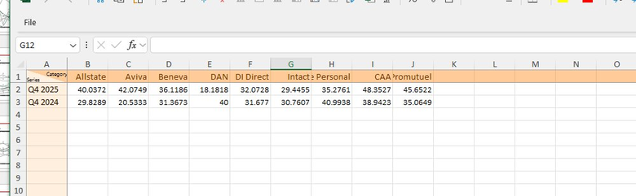
The full output covers all 8 combinations across the sheet — each table placed in the designated cell range for the macro.
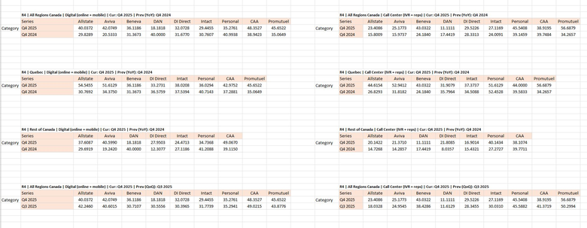
Each labelled block corresponds to one slide — region, channel, current period, and comparison period are all specified in the block header. The macro reads from these fixed positions and populates the think-cell charts without any manual intervention.
EXAMPLE B — COMPLEX CASE
Brand Attributes Chart
Interactive CLI · Analyst selects filters at runtime · Stat sig automation

The slide
The target output is a brand attribute chart showing % top 2 box scores (scores 6 or 7 on a 7-point scale) for 10 attributes across 5 providers, with three rolling time periods and statistical significance arrows indicating meaningful change vs. the comparison year.
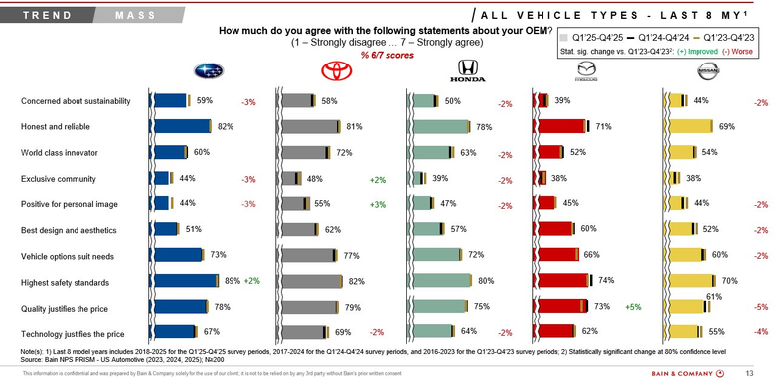
Unlike the CNPS example, the filter combinations here are not fixed. The provider set, wave periods, and model year ranges are selected by the analyst depending on which slide is being built — Luxury vs. Mass Market, All Vehicle Types vs. Sedan vs. SUV. This is why an interactive approach is needed rather than a static script.

Why this requires an interactive approach
- Subjective filter combinations: The analyst decides which provider tier, vehicle class, wave windows, and model year ranges apply to each slide. These change between slides and between engagement managers' requests.
- Model year ranges shift every wave: The Last 8 MY definition changes each year — hardcoding it would require code edits every refresh. The CLI forces the analyst to make this selection explicitly, reducing the risk of a silent error.
- Three separate time periods per run: Current, prior year, and two years prior — each with its own wave set and model year window. Six separate filter selections that cannot be auto-detected.
- Statistical significance: 50+ individual z-tests per run in the manual process. The tool computes these automatically at 85% confidence and assigns arrows — no reference sheet needed.
Feature highlight -- Automated statistical significance
In the manual process, significance must be computed for every attribute x provider combination using a separate reference spreadsheet -- typically 50+ individual z-tests per run. Time-consuming and prone to silent errors.
This tool computes significance automatically. For each attribute and provider it runs a two-proportion z-test: Set1 (current) vs Set3 (two years prior) at 85% confidence (|t| >= 1.282). Result assigned directly as a symbol in the output.
Arrows appear directly in the Excel output ready to paste into the slide. No manual significance calculations are required.
Feature highlight -- Interactive filter selection via terminal
Filter combinations are subjective -- provider tier, vehicle class, model year ranges, and wave periods change depending on which slide is being built. Hardcoding these requires code edits every run; wrong values produce incorrect without an obvious error outputs.
The tool runs an interactive terminal session instead. The analyst types numbered selections at each of 9 prompts -- no code editing, reducing the risk of incorrect hardcoded values. Provider column order is entered in the exact left-to-right order matching the slide.
Every selection is logged to the Summary sheet automatically, creating a full audit trail per run. If a filter selection was incorrect, re-run the tool with the corrected values.

Step 1 — Load the data
The respondent-level data extract is uploaded. Claude reads the structure — one row per respondent per attribute — and understands the key columns used in the calculation.
Column | What it contains
Brand Attr Num Answer | Score 1–7 given by the respondent for each attribute
Brand Attr Gid Respondent | Unique respondent ID — used for distinct counts
Nam Provider 2 | OEM brand name
Flg Provider Tier | Luxury or Mass Market
Cls Product Model 2 | Vehicle class — Sedan, SUV, Truck, Van
Desc Wave | Survey wave label — e.g. 2025 Q1
Model Year | Vehicle model year

Step 2 — Ground Claude on the calculation
The QC pivot is shared as a screenshot. This shows Claude the numerator (distinct respondents scoring 6 or 7) and denominator (total distinct respondents), producing the % top 2 box figure for a specific provider and filter combination.
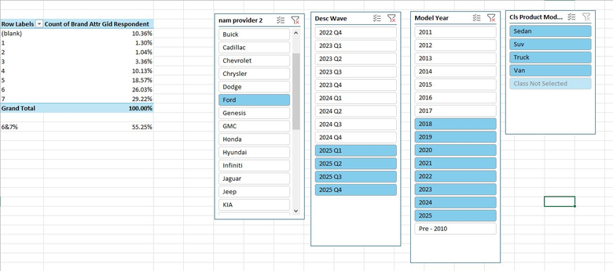
Alternatively, the Tableau tooltip formula can be shared directly. Either approach works — the goal is for Claude to understand the exact aggregation logic before writing any code.
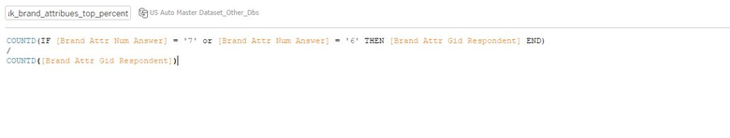
Claude is asked to compute the value for one provider, one attribute, and one wave window first. That single output is validated against the dashboard before Claude is asked to build the full multi-provider, multi-period output.

Step 3 — Interactive CLI for filter selection
Rather than hardcoding filter values, the tool presents numbered menus at runtime. The analyst types index numbers — never full names — making the process fast and less error-prone. The full sequence of prompts is:
1 | Provider tier Luxury / Mass Market  Type 1 for Luxury or 2 for Mass Market.  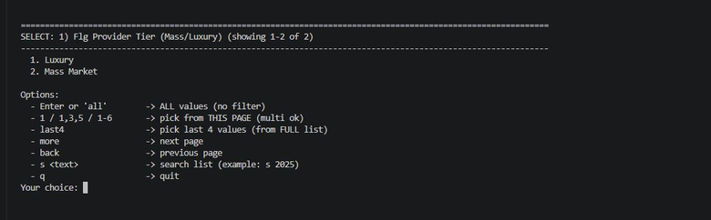
2 | Vehicle class All types or a specific class  Type "all" for the full slide, or a number for Sedan, SUV, etc.  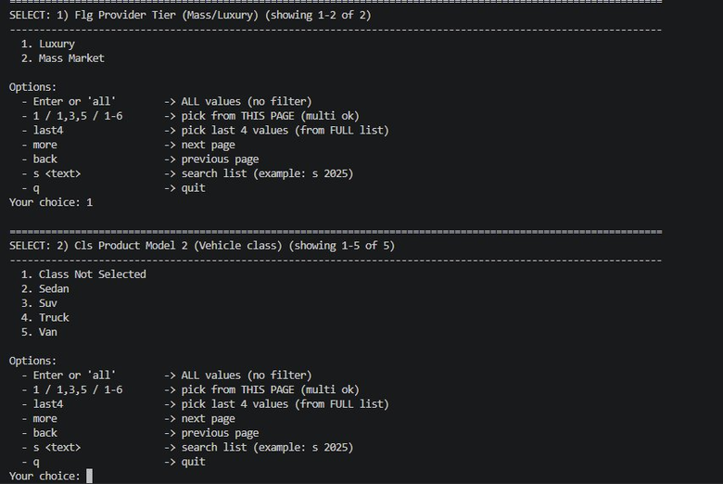
3 | SET1 waves — current period Most recent 4 quarters  Comma-separated index numbers for the 4 quarters in scope.  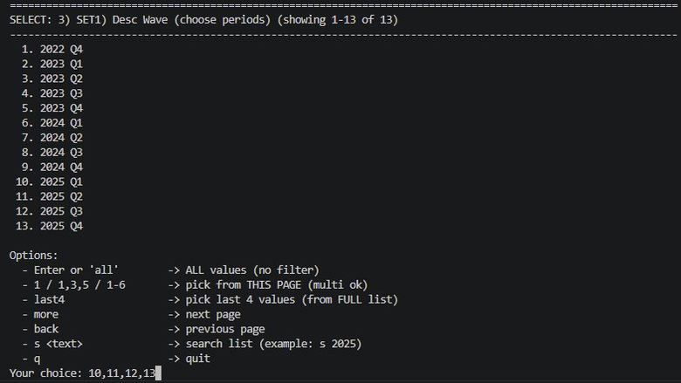
4 | SET1 model years Last 8 MY for current period  For 2025 waves: 2018–2025, indices 8–15.  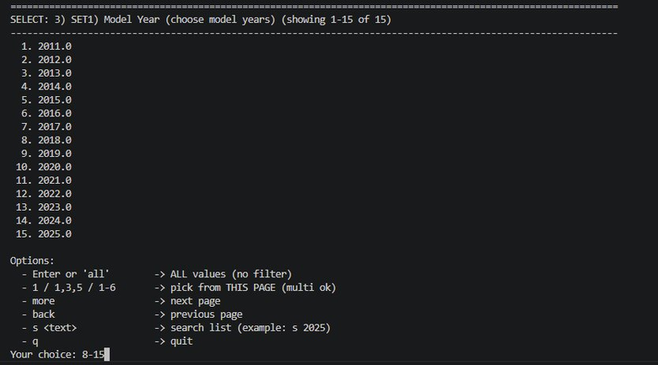
5 | SET2 waves — prior year One year back  Four quarters from the prior year window.  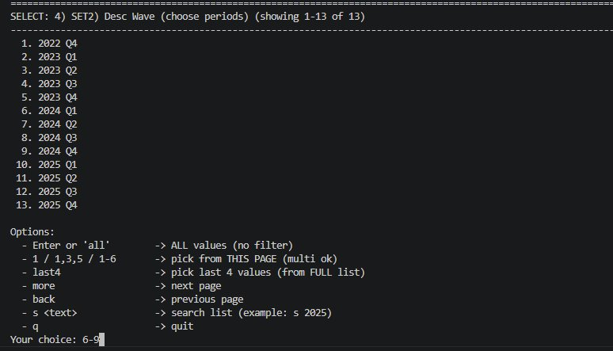
6 | SET2 model years Last 8 MY for prior year  For 2024 waves: 2017–2024, indices 7–14.  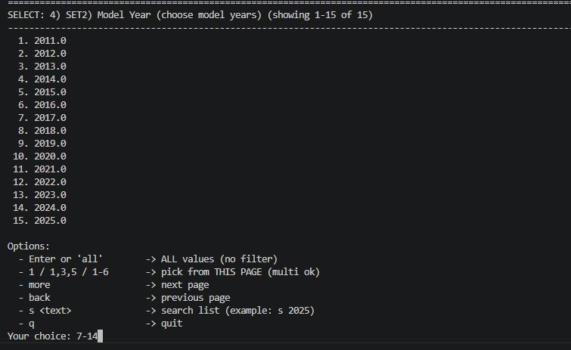
7 | SET3 waves — two years prior Comparison base for stat sig  Four quarters from two years prior.  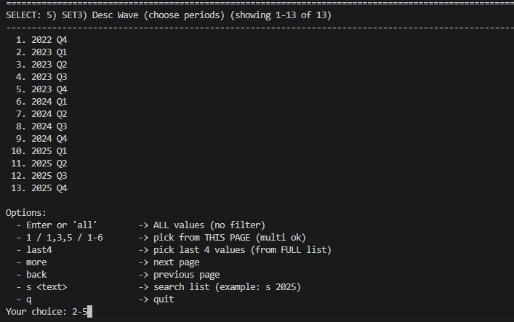
8 | SET3 model years Last 8 MY for two years prior  For 2023 waves: 2016–2023, indices 6–13.  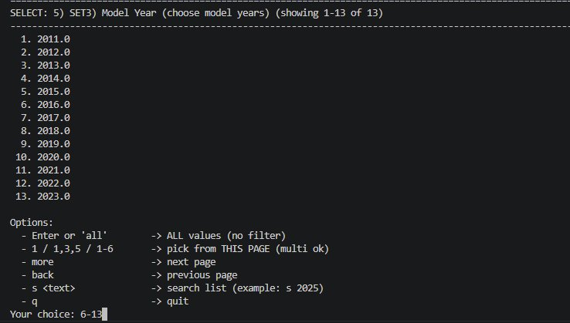
9 | Provider selection and column order Left-to-right slide order  Type index numbers in the exact order providers appear on the slide.  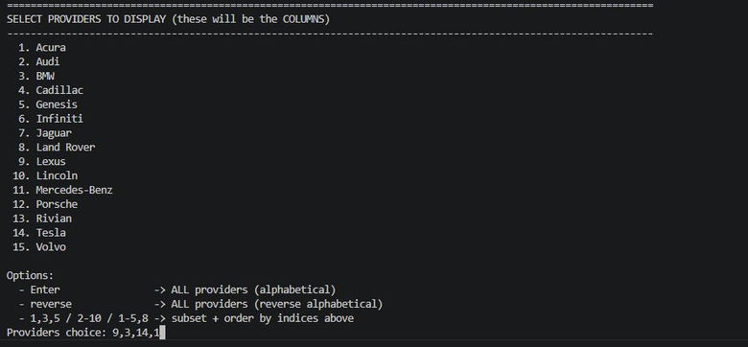

The output
After the prompts are answered, the tool computes all values and prints a per-provider summary in the terminal for a first QC check.
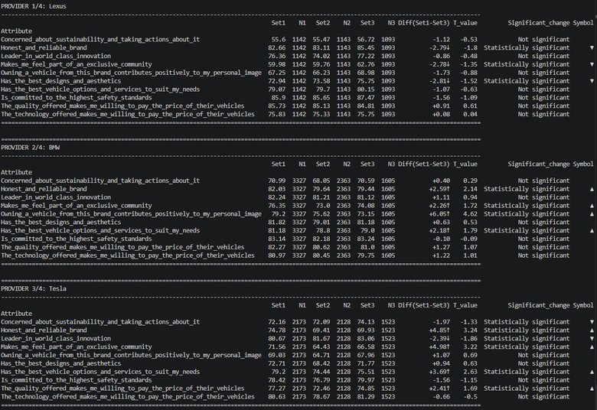
The Excel output has two sheets. Sheet 1 contains the data — attribute rows with Set1, Set2, Set3, Diff, and Symbol columns per provider, ready to paste into the think-cell backend.
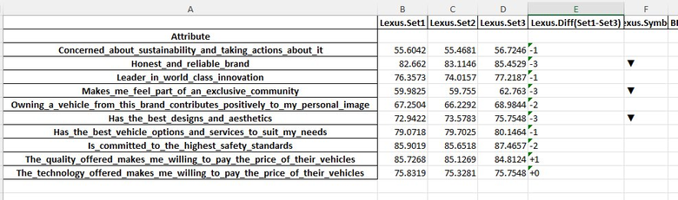
Sheet 2 is a summary of every filter applied — tier, vehicle class, all three wave sets, all three model year sets, provider order, and significance rule. This is the audit trail.
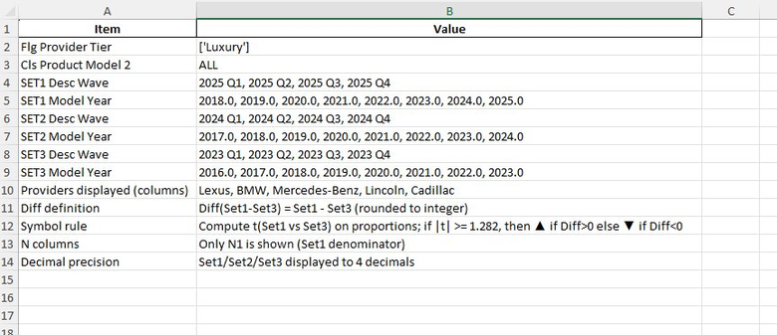
Always verify the summary sheet before pasting data into the slide. If any filter is wrong, re-run the tool. Do not manually edit the data sheet.

4. Choosing the right approach
Both examples follow the same three-step methodology. The choice between a static script and an interactive CLI depends on one question: are the filter combinations fixed, or does the analyst need to make decisions at runtime?
Signal | Use static code (Example A) | Use interactive CLI (Example B)
Filter combinations | Fixed and predictable — same structure every wave | Variable — change by slide, by engagement manager request, or by scope
Period selection | Can be auto-detected from the data | Must be explicitly chosen — rolling windows, model years, comparison bases
Provider set | Same providers every run | Provider set and order change between slides
Refresh frequency | Run every wave with no changes | Run whenever a specific filter combination is needed
QC approach | Validate once when built; trust on subsequent runs | Summary sheet provides audit trail for every run

5. Where else this methodology applies
The three-step approach — load data, ground Claude on the calculation, specify the output format — applies to any slide where the underlying computation is repetitive and manual error is a real risk. Examples:
Slide type | Static or interactive | What the code replaces
NPS inflow/outflow switching | Static | Multi-period switching rates across providers, auto-detected rolling windows
Segment profiles (income, age) | Static | Same metric across demographic cuts — repeated filter combinations
Funnel conversion by provider | Static | Stage-by-stage conversion rates across OEMs for multiple waves
Driver analysis (key NPS drivers) | Interactive | Attribute importance scores — subjective segment and period selections
Competitive benchmark tables | Static | Any repeated cross-provider metric table updated each wave
Episode NPS deep dive | Interactive | Episode-level NPS with multiple episode type, region, period combinations
The more times a slide is updated across the engagement, the higher the payoff of building the automation. A slide updated every wave for 6 waves repays the setup time within the first two runs — and eliminates the QC risk on every subsequent run.

6. Summary
Step | What you do | Why it matters
1. Load the data | Upload the view data extract or respondent-level file to Claude. Describe the columns and how the data is organised. | Claude understands the data structure before writing any code — no guessing about field names or aggregation logic.
2. Ground Claude on the calculation | Share a screenshot of the Tableau formula or a QC pivot. Ask Claude to replicate one value. Validate against the dashboard. | This is what makes the output trustworthy. One validated cell prevents errors across hundreds of computed values.
3. Specify the output format | Describe rows, columns, period definitions, provider order, significance rule, and cell mapping. Share the slide and backend screenshots. | Claude generates code that produces an output you can paste or macro-load directly — no reformatting.
4. Run the code | Static: just run the script. Interactive: answer the numbered CLI prompts for each filter dimension. | No code editing between runs. Built-in audit trail. Faster to re-run for any filter combination.
5. QC the output | Check the terminal preview (interactive) or the summary sheet (both). Verify before pasting. | QC is built into the tool itself — not a separate manual step requiring a reference sheet.
The core principle
The goal is not to replace analytical judgment — it is to remove the mechanical, repetitive steps that consume time and create QC risk. By grounding Claude on the calculation and validating before scaling, you get the speed of automation with the trust of a manually verified output. Example A shows this for a fixed-structure slide. Example B shows it for a slide where the analyst's judgment drives the filter selections.

